**‘COOKING WITH CONFIDENCE’**

**Start the New Year by join The Real Food Team and other community members for our**

***FREE***

**Cooking Sessions**

**Learn simple cooking skills to help you eat well for less.**

**At the end of the session you get to eat the delicious food!**

**When: Every Friday starting 18th January 2019**

**Where: Unit-e (in the Civic Centre between Farm Foods and The Chip Shop)**

**What time: 10.30 am – 1.30 pm**

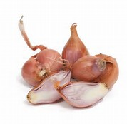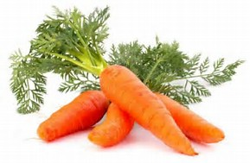

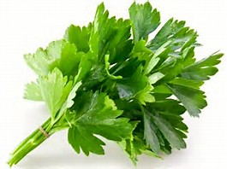

**For further information or book contact:**

**Email:** [enquiresrealfoodteam@wchg.org.uk](mailto:enquiresrealfoodteam@wchg.org.uk)

