Wythenshawe Community housing group & forum trust
Open4funding Guide
An easy guide to searching for funding
Alasdair Ricard
11/17/2016

This document will guide you through funding searches and give you access to a free accessible search engine with upto date funding available to a range of organisations.

www.Idoxopen4community.co.uk/wchg
Simple Training Guide
The open4 website is a really useful resource for anyone looking to apply for funding.
This guide I will be explaining:
- The registration process
- Searching for funding
- Saving your results
- Email notifications

Step 1: Register
Before you can access the sites searches / funding pages you must first register.
This process it quite simple
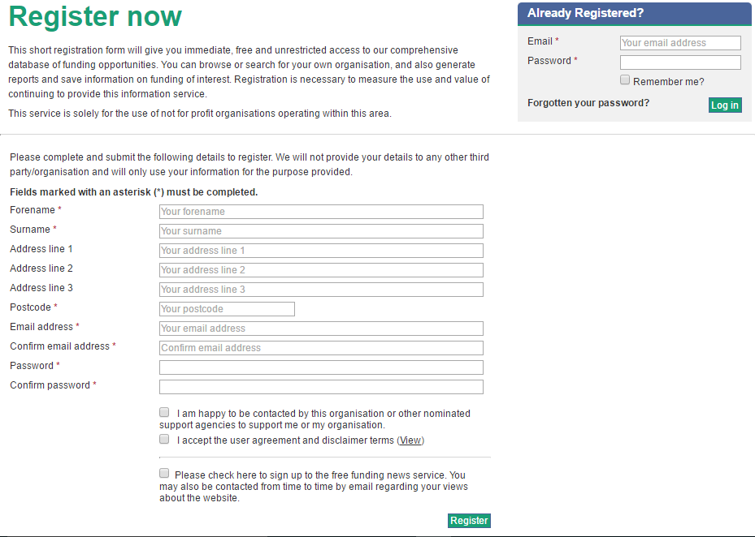

To complete the registration process you must fill in all boxes marked with a * and accept the User Agreement. Once you have registered with a valid email address you will be able to use the search features.

Step 2: Searching for funding
There are two ways you can search for funding on the Open4 website.
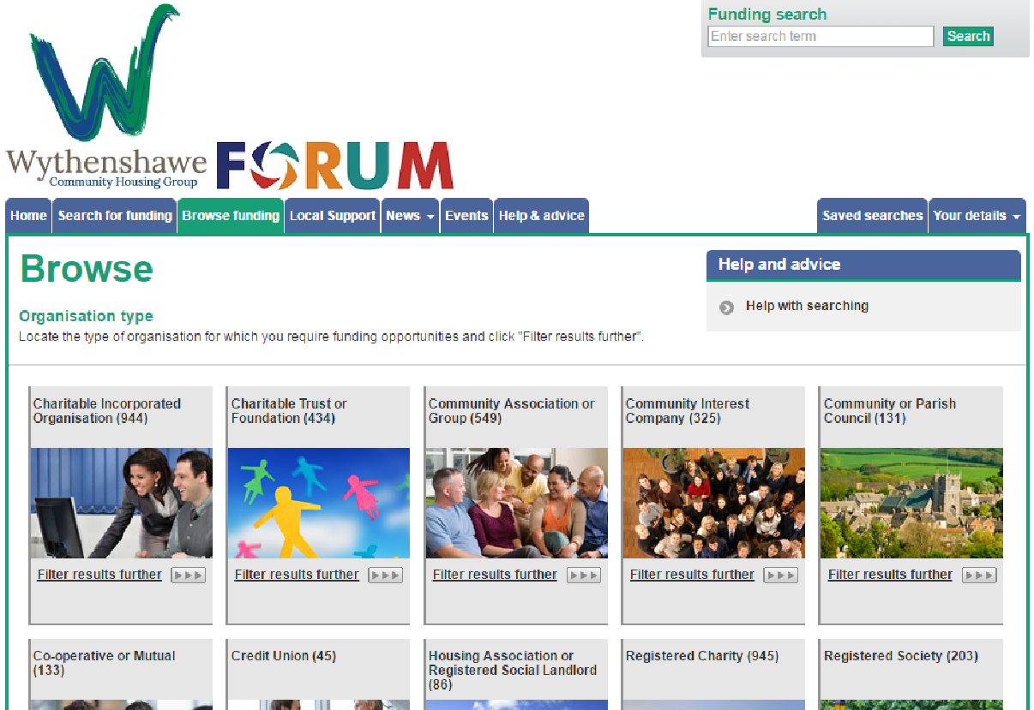
Category Browse Organisation type

This type of search allows you to select the category of your organisation.
Once you select your organisation type the site will list funding / grants that are currently open for you to apply for
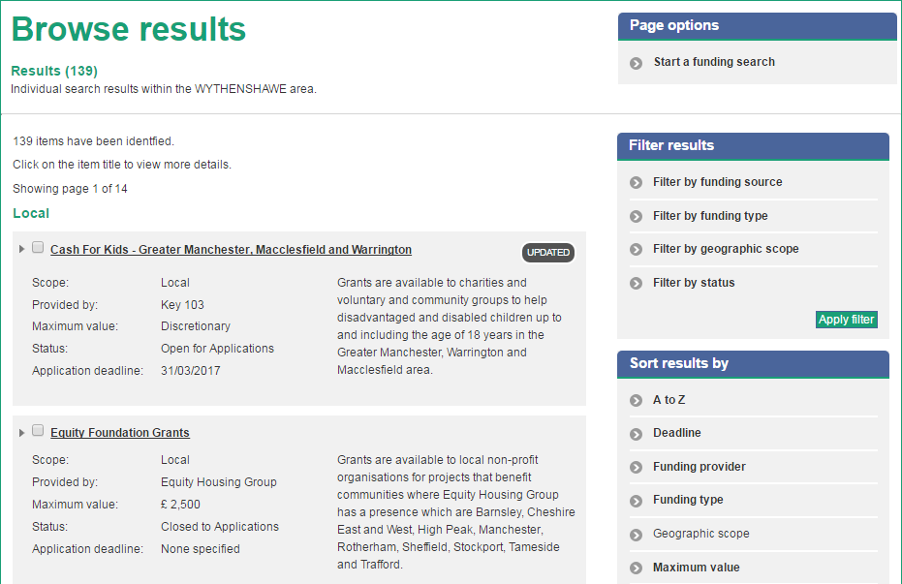

Custom search
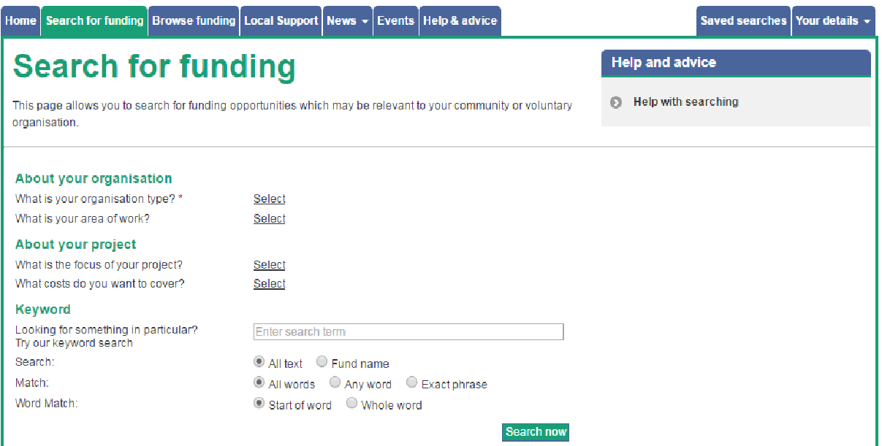
This search allows you fully refine the results of your funding search by using the additional information you provide to filter out funding / grants that are not relevant to your organisation
Your search results will list all funding / grants your organisation can apply for and give you some basic details including:
- Scope
- Provider
- Max amount you can apply for
- Currently accepting applications
- Deadline for applications
You can click on each to find out more details and find out how to apply
For more information on the www.Idoxopen4community.co.uk/wchg website : Contact Alasdair Ricard - Digital Inclusion on 07580 870 450 | Alasdair.Ricard@wchg.org.uk

