Appendix A
Tenant Alteration Form

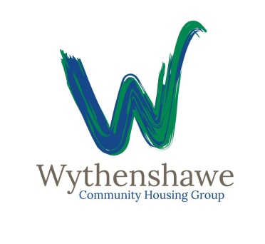
Application to make your own
Improvement or alteration
We welcome people making their own improvements, but we insist you obtain our written agreement first. We will only say ‘no’ if there is a good reason – if the work would affect your neighbours, or be unsafe for example.
Your name …………………………………………………………………………………
Address …………………………………………………………………………………….
………………………………………….Postcode………………………………………..
Phone number (Daytime)…………………………………………………………………
Where is the improvement you want to make?
Outside
Inside
Inside & outside

If inside, which room(s) will be affected?
………………………………………………………………………………………………
Brief description of the work you want to do.
………………………………………………………………………………………………………………………………………………………………………………………………………………………………………………………………………………………………………
………………………………………………………………………………………………….
………………………………………………………………………………………………….
………………………………………………………………………………………………….

Have you got all the necessary permissions (planning/building regulations if required?)
Yes

No

None required

What is the name of the contractor you are going to use?
Builder ……………………………………………………….
Gas Engineer ………………………………………………. Gas Safe No………………
Electrician …………………………………………………... NICEIC No…………………
FIRAS Accredited Inspector ……………………………………………
If we give permission, when will you start the work? ………………………………
When do you expect to finish the work? …………………………………………………..
How much do you expect the work to cost? ………………………………………………

If you carry out this work you must agree to pay for Wythenshawe Community Housing Group to put right any problems that are caused during the work or after the work has been done.

I Agree (Signature) ………………………………………………………………………….
- Please attach a plan of the improvement you want to make, and copies of any survey reports and permissions.
- Please attach a copy of the quote from the contractor on letter-headed paper. Please note you should not pay for a quote or pay for any work before all work is completed.
- If you live in a flat in a three-storey block or a high-rise block we will also require a certificate on completion of the work from a FIRAS accredited inspector to show that fire safety in the block has not been breached.

You can hand this form into any of our offices or send it back to Wythenshawe Community Housing Group 307 Greenwood Road, Wythenshawe, Manchester M22 9HD. If you would like more information please ring 0300 111 0000 or 0800 633 5500.
Examples where permission is likely to be granted:
- Smart meters, water meters
- Fencing to front of property not exceeding 4 feet high
- Installation of internet services (subject to inspection by FIRAS accredited inspector in high-rise blocks)
- Bathroom alteration
- Kitchen alteration
- Laminate flooring
- Patio doors
- Moving radiators
- House alarms

We do not grant permission for:
- Loft conversions
- Extensions
- Conservatories
- Fencing to front of property over 4 feet high

OFFICE USE ONLY
Check works completed (date) ……………………………………………………………..

Work satisfactory? Yes
No

Actual cost ……………………………………………………..

Receipts received (date) ……………………………………….

Wythenshawe Community Housing Group to maintain? ………………………………..

Date …………...................

Surveyor …………………………………………………………………………………….

Signature …………………………………………………………………………………….

