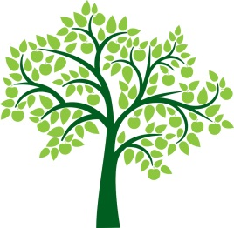
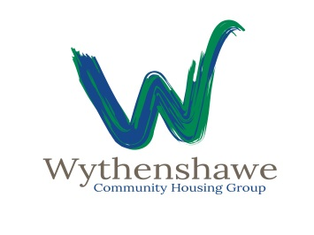

Withy Tree Youth Bank

Application Form

Organisation Name/Project
Amount being applied for?
Target age Group
How many young people will benefit from the funding?
Outline of what you will spend the money on. Max 400 words
What makes this youth friendly? Max 200 words
What makes you stand out? Max 200 words
Why should we choose you? Max 200 words
What involvement have young people had in creating this idea? Max 150 words

